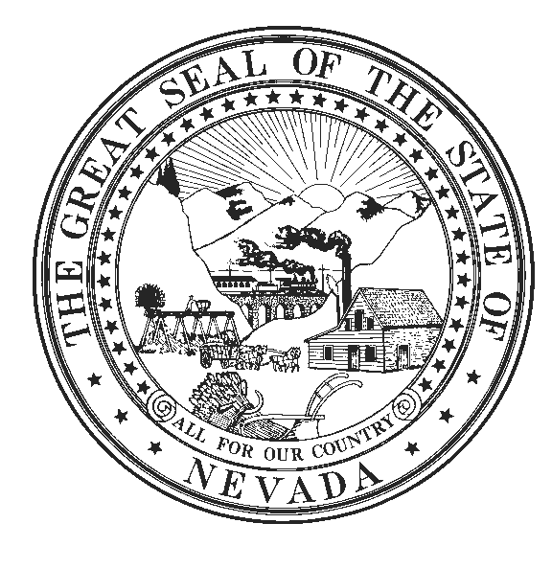

DISTRICT OFFICE:
68 Amigo Court
Sparks, Nevada 89411-6213
Cell: (775) 221-2502
Fax No: (775) 322-8889
Email: irahansen@irahansen.com

LEGISLATIVE BUILDING:
401 South Carson Street
Carson City, Nevada 89701-4747
Office: (775) 684-8851
Fax No.: (775) 684-8533
Email: Ira.Hansen@asm.state.nv.us
www.leg.state.nv.us
IRA HANSEN
ASSEMBLYMAN
District No. 32

COMMITTEES:
Member
Commerce and Labor
Judiciary
Natural Resources,
Agriculture, and Mining

State of Nevada Assembly
Seventy-Seventh Session

June 2, 2013

AMENDMENT TO SB 123

To help insure protection for the ratepayers, and after consultation with PUC staff, here is the amendment.

Thanks,

Ira

