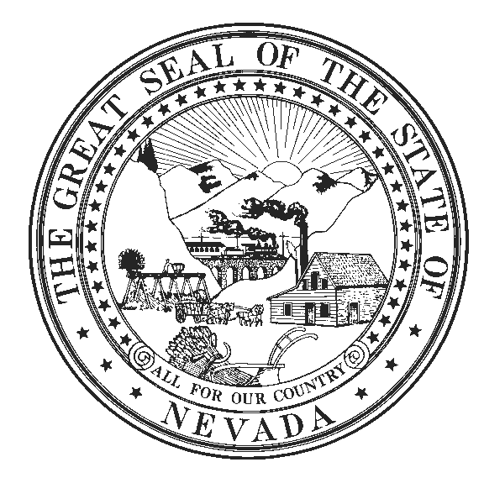

DISTRICT OFFICE:
68 Amigo Court
Sparks, Nevada 89411-6213
Cell: (775) 221-2502
Fax No: (775) 322-8889
Email: irahansen@irahansen.com

LEGISLATIVE BUILDING:
401 South Carson Street
Carson City, Nevada 89701-4747
Office: (775) 684-8851
Fax No.: (775) 684-8533
Email: Ira.Hansen@asm.state.nv.us
www.leg.state.nv.us
IRA HANSEN
ASSEMBLYMAN
District No. 32

COMMITTEES:
Member
Commerce and Labor
Judiciary
Natural Resources,
Agriculture, and Mining

State of Nevada Assembly
Seventy-Seventh Session

June 2, 2013

SENATE BILL 123

How many lobbyists do the 2 million+ ratepayers for NV Energy have? NONE

How many lobbyists does the now-owned-by Warren Buffett-NV Energy have? YOU KNOW THAT ANSWER

On SB 123, we have been told the Public Utilities Commission (PUC), the protector of the ratepayer, has been heavily involved. This is false, and the PUC has in fact been almost left out of the significant decision-making. To prove this point, I requested a date-and-timeline of the meetings that the PUC was involved in.

IT IS ATTACHED
Please carefully review and make up your own mind

SB 123 may be the most important bill this session. It involves at least $750 million to well over $1 billion dollars’ worth of spending. And guess where the money is to come from.

To address their needs I have asked them to specify the changes needed in the bill. The amendment for SB 123 will be sent shortly.

Ira

