June 10, 2013

Robert Levering
CEO
Great Place to Work Institute
222 Kearney Street
San Francisco, CA 94108

Re: Station Casinos and Your “FORTUNE 100 Best Companies to Work For” list

Dear Mr. Levering,

Your firm has been hired by Station Casinos LLC to conduct an employee survey. This appears to mark the start of the Las Vegas company’s application to be on the “FORTUNE 100 Best Companies to Work For” list, which the Great Place to Work Institute produces every year.

You should know that Station Casinos has broken federal labor law eighty-eight (88) times, making it the worst labor law-breaker in the history of the Las Vegas gaming industry. And it has refused to listen to its workers, even after a majority of those in the Culinary and Bartender Unions’ bargaining unit signed and presented a public petition demanding a fair process. A fair process is a standard method in the Las Vegas gaming industry by which workers can decide whether to unionize in a way that is free from management interference, intimidation, bullying, or litigation. The company has ignored its workers’ demand even after a seven-day fast by nine Station Casinos workers, demonstrations by thousands of community and union supporters, civil disobedience arrests, and requests by local clergy leaders to mediate the labor dispute. For more information, please go to www.WorkerStation.org.

Instead, Station Casinos has trumpeted its previous inclusion on the “FORTUNE 100 Best Companies to Work For” list in response to its employees’ organizing efforts.

- “[Company spokesperson Lori] Nelson highlighted Station’s distinction as one of Fortune Magazine’s “100 Best Companies to Work For” four years in a row, through 2008. She also noted the company’s on-site child care and its in-house programs to help employees purchase homes and become citizens. (“Station Casinos workers seek refuge with Culinary Union”, Las Vegas Sun, 3/13/2010)
- “Fortune Magazine has named our company one of the 100 best companies to work for four years in a row," [Station Casinos’ Lori Nelson] said. "There’s never been a gaming company and there has never been a culinary union-represented property that has ever received that kind of recognition before.” (Immigrant workers, casino owners wage war of words over unionization efforts”, Public Radio International, 4/23/2013)

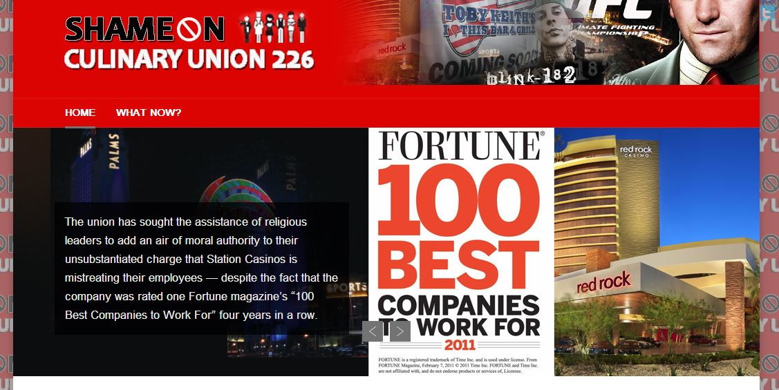
We believe your firm is not involved in Station Casinos’ illegal attacks on its employees and their right to organize. Nevertheless, if Station Casinos is named to the “FORTUNE 100 Best Companies to Work For” list again, we believe it will only further associate the Great Place to Work Institute and your “FORTUNE 100 Best Companies to Work For” list with this vehemently anti-union employer and its history of worker rights violations.
Screen capture (on 6/6/2013) of an anti-Union website, Shame on Culinary Union 226 (www.shameonculinaryunion226.org), showing Station Casinos’ Red Rock Casino accompanied by the cover of the 2011 FORTUNE list, which did not include Station Casinos.

Please contact us immediately if you have concerns about the reputational risk related to Station Casinos. We hope to hear from you within 10 days. I can be reached at 702-387-7001.

Sincerely,
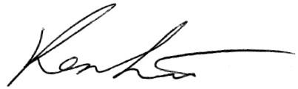
Ken Liu
Research Director

http://www.lasvegassun.com/news/2010/mar/13/station-workers-seek-refuge-culinary/
http://www.pri.org/stories/business/immigrant-workers-casino-owners-wage-war-of-words-over-unionization-efforts-9565.html

